**Practitioner Interview**

Date: 05/03/2015

Participant Name: Mark Rainey

Role: Front End senior Developer

Company: Compare theMarket (Part of the BGL group)

**Discussion Notes:**

**Background of role**

As this is a large IT organisation, each product on their site is separated into teams and each responsibility is separated into logical areas. This can often mean the system structure can differ from product to product, even page to page. This results in a consistent theme for each product, however often both the front end mark up and backend design can be completely different; this is often down to the fact that the organisation offers developers the freedom to developer in an area of their expertise. This results in projects that use some of the latest tools and techniques that meet the requirements set. Mark mentioned a possible solution to the problem, is developer their own unique web application framework that keeps the UI structure and layout consistent across the whole business.

**Responsive Tools:**

Flex box is a layout mode providing for the arrangement of elements to predictably change, when the page layout must accommodate different screen sizes and different display devices. This is a direct alternative to bootstrap grid system; however the concept for responsive design differs slightly. With bootstrap, the grid system works by triggering elements properties to change when a screen or viewport is of a certain size. This is often through the use of media queries and JavaScript functions. Flexbox’s concept evolves around the idea if an element can no longer fit on a screen, it must change its properties and position accordingly through the use of CSS3.   
A key advantage stated by the practitioner about responsive site design was the fact that responsive systems are much easier to maintain. If a change is made it will have effect on all devices rather than if the website is split into two systems, one for mobile and one for desktop, changes would need to be made on each system. It also means that style properties could respond differently on different devices so they make break the consistency of the theme. This is what they stated was called device driven responsive design.   
They found setting up flexbox extremely difficult at first and it took several attempts to get it to work properly

**JQuery vs AngularJS**

During the interview, the practitioner discussed a great benefit of angular.js compared to jQuery that to this point had not been considered. JQuery requires an element to be identified by an attribute node, in order to trigger an event or for an element to be manipulated. For a large firm, this can often mean that a small change like changing a class name in the mark up can result in an a impact in the JavaScript not functioning correctly. Using angularJS a databinding control can be placed inside an element tag that is separate to an attribute node. A front end developer would have no reason to need to alter the control and allows the two areas to work completely separate, with no direct dependencies.

**SASS**

The practitioner used SASS over LESS for no particular reason; SASS was already integrated into the development environment so this was the easier compiler to use. The practitioner emphasised on why not using some sort of CSS extension would be bad practise, and as SASS structures styling identifiers in parent/child structure, the same way it’s structured in a HTML document it logically makes more sense.

**Bootstrap**

The practitioners initially demonstrated the large amount of use bootstrap grid system is used throughout the compare the market product side of the website and explained how well it worked making their site responsive. He also demonstrated how they had implemented a whole section of their site using bootstrap that presented the exact same design as other areas of the site where bootstrap hadn’t been used. He stated how bootstrap works extremely well for a new project or website, but the integration for an established site became extremely difficult and complex. He said the grid system is superb but the attributes required to use the frameworks capabilities completely goes against semantic principles. In a large organisation like theirs, many different developers can often work on one site, and it can become hard if there isn’t clear semantics.   
They also stated how they had used a bootstrap version that style properties and behaviours had been compiled using sass rather than less. This helped the integration into their project environment a lot easier.  
  
**Single page applications**

They try use single page application design with angularJS routing as much as possible, as tests have shown that content loads quicker and provides a better user experience. They also prefer the fact that data isn’t passed around from page to page.

**CDN’s**CDN’s are always used unless they require only a certain sections of a framework or tool. They stated how they had created their own cdn for all images used on all projects within the organisation so all developers have access to the same logos and brand images. This was crucial for them as if they decided to, for example, tweak their logo, they only had to change it in one place, and all areas of the website would then change to the new logo.

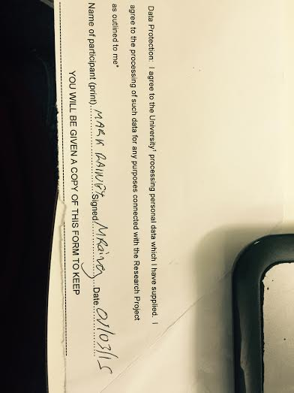**Practitioner Data protection Acceptance**